Anywhere Anytime Reporting

Automating Automation through Right Reporter®

Computer systems were initially developed to make the process of data gathering and retrieval faster and easier. However, with the increasing need for information access and analysis, IT departments today often have to hire programmers to develop varied reports from various sources such as databases, xml files and text files.

This is a time-consuming and expensive process where the IT department’s limited bandwidth has often resulted in delays that end-users can ill afford.

Fortunately, there is a quick and easy solution – Avman’s Right Reporter.

Right Reporter has automated the report design and creation process so that after the initial assistance from the IT department to install the system, end-users can create complex reports directly, without compromising security.

Alternatively programmers can use Right Reporter to save days, weeks or even years of work involved in creating reports.

Right Reporter takes less than five minutes to install and creates complex drill-down and cross-tab reports.

It’s simply, savvy reporting at your fingertips.

Right Reporter is the registered trade mark of Avman Systems Inc. All other trade marks belong to their respective companies.

Table of Contents

The Anywhere Anytime Reporting Revolution 1
Automating Automation through Right Reporter 1
Executive Summary 3
History of Reporting 3
Disadvantages of Traditional Client-server Technology for Reporting 4
Fat Clients 4
Right Reporter to the rescue – 100% Web based reporting 6
Features of Right Reporter 7
Right Reporter – Lite 8
Right Reporter – Professional 8
Right Reporter – Enterprise 8
Right Reporter – 508 9
Usage of Right Reporter 9
Right Reporter as a stand-alone reporting system 9
Right Reporter as an embedded application 10
Right Reporter in an ASP/Enterprise scenario 11
Features 12
Summary 12
Contact Information 13

Executive Summary
Few organizations realize that in large- and mid-sized Enterprise Resource Planning (ERP) systems, the cost of the reporting system is substantial. It typically constitutes 30% to 50% of the development cost.

However, this increases after the system is implemented. After deployment maintaining reporting typically constitutes 50 -70% of the cost of on-going support. This is due to the fact each time end-users need to change or create a new report, they need to approach the stretched IT department again and again – no matter how minor the change may be. For example, adding a single new field to a report may result in weeks of waiting while the request is forwarded, approved, queued and finally acted upon. And in some cases, to the detriment of the business, the request may never be fulfilled as it is seen as low priority or there is insufficient IT manpower to act on it.

In contrast, Avman has come up Right Reporter – a set of time- and cost-saving tools that make developing reports a cinch, and at a fraction of the expected cost. For example, in an implementation for a US school district, the Right Reporter solution was implemented at a fraction of the projected cost.

History of Reporting
- Reporting is the key ingredient of all information systems
- COBOL-, RPG- based reports were the forerunners to current reporting systems
- SQL brought about the revolution in ad-hoc reporting

In the corporate world, the competitive advantage comes not from data capture alone, but from analysis. Hence, from the time of some of the earliest programs, reporting has been key.

Even during the reign of COBOL as the key programming language, about 80% of all programs were reporting-related.

In order to increase efficiencies in programming of reports, several efforts followed. In the 1960’s one of the most notable efforts was IBM’s development of RPG (Report Program Generator), which is still in use in many organizations today.

The next reporting revolution came with the growth of relational databases and Structured Query Language(SQL). Databases made it easier to store and retrieve information and yet maintain its integrity. SQL used an English-like syntax for ad-hoc queries.

Central Database Server
Client Software
Client Software
Client Software
- Client-server technology is still the most widely used technology
- Client-server has several drawbacks that can be overcome by Web-based systems
Structure of client-server applications

With the rise of client-server technology, central databases located on servers could be accessed by end-users’ client PCs. While this technology is still the most widely used in the world today and has key advantages over the previous mainframe- and mid-range based proprietary systems, it still has many drawbacks.

- Current reporting tools still have great dependencies on programming
- Licensing fees for client-server- based tools
- Tools do not differentiate between users, designers and programmers

Disadvantages of Traditional Client-Server Technology for Reporting

Fat Clients
Most client-server-based reporting tools require large modules of the reporting application installed on client PCs, resulting in “fat clients”. As each client PC could have a different configuration that directly impacts how effectively it can access the central databases, the cost, time and skill sets needed for maintaining such systems is high. In addition, the heavy processing needed on the client PC necessitates high-power, expensive client PCs that substantially increase the hardware cost.

Central Database Server
Report Designers Client Software
Web Server
Browser Based ersers
Conventional client-server based reporting tools with added modules only partially utilize the Web’s cost-saving abilities

- Extra client software, server software, hardware
- IT department’s involvement essential
- License issues for each designer seat
- Larger number of programmers results in more licensing fees
- Long development lifecycle
- Report Designer needs to communicate frequently with programmer
- Deployment issues
- Database connections in test and live environments can be different
- Consistency issues
  - Each report must look and feel the same
  - Time-consuming to standardize and maintain colors, headers, fonts across multiple reports
- Security Issues
  - Users can often view reports that they are not authorized to view
  - Users can often only view part of the data needed i.e. horizontal slicing of data is unavailable
  - Causes a large number of reports to be ‘hard coded’

The above issues contribute towards
- Cost
- Time
- “Chatter”

Right Reporter to the Rescue – 100% Web- based Reporting

“The ideal project is one where people don’t have meetings, they have lunch. The size of the team should be the size of the lunch table” – Bill Joy (Cofounder Sun Microsystems, Godfather of Java) in an interview with Wired Magazine.

Central Database Server
Programmers
Web Server
Right Reporter
Designers
Users
- Right Reporter fulfills the deficiencies of client-server-based reporting tools
- 100% Web reporting
- No downloads
- No plug-ins
- No installation on client machines
Right Reporter allows users to program, design and run reports on the Web for anywhere, anytime access

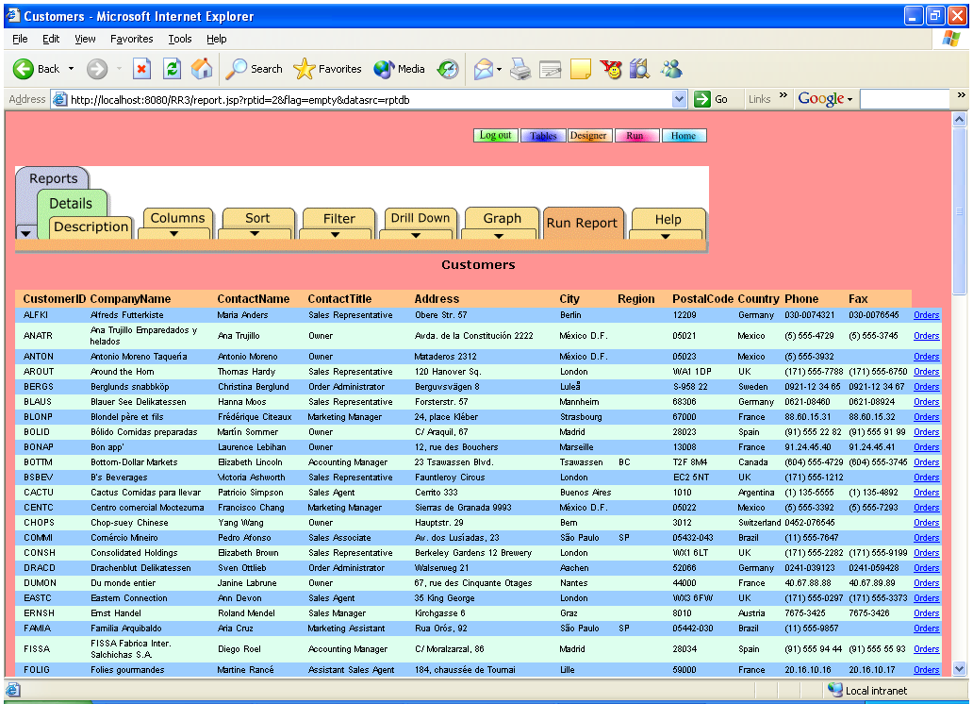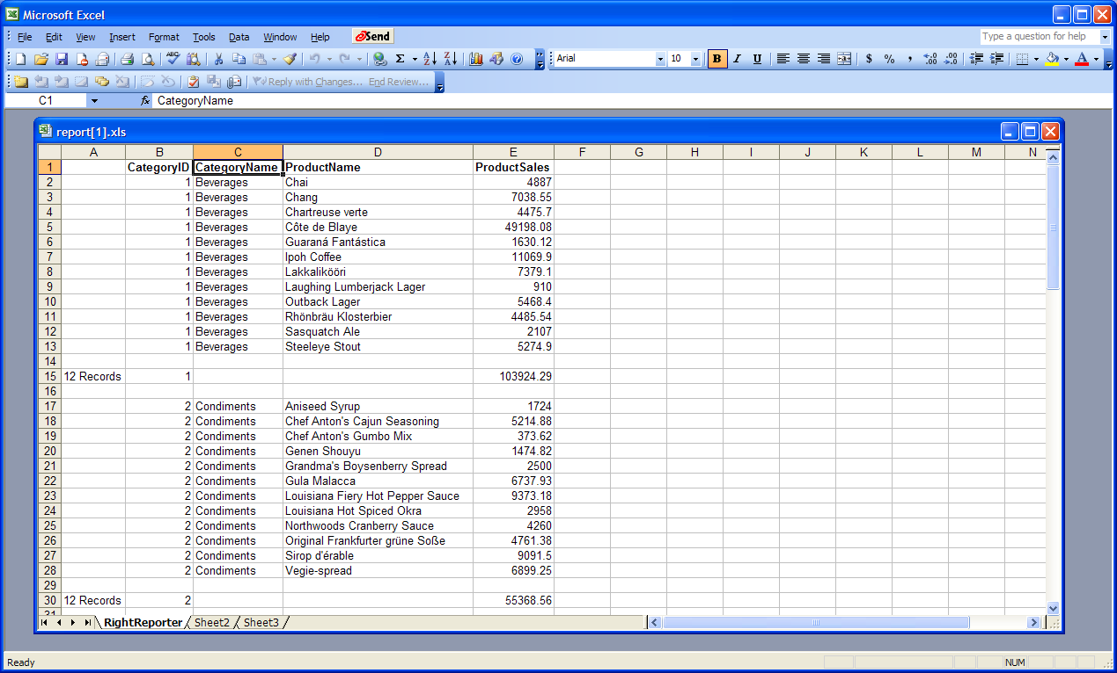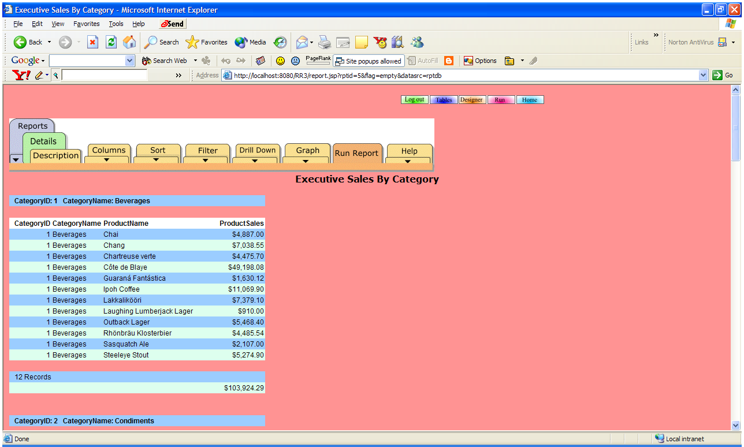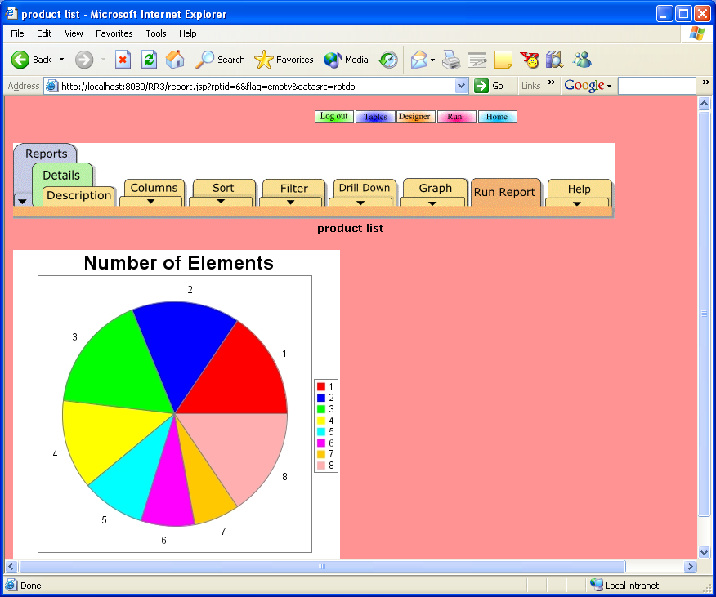
Right Reporter creates multiple types of reports by simple clicks of a mouse

Users
Designers
Servlet Engine
JDBC ODBC
Central
Database
Right Reporter®
Mail Interface
WAP Interface
Web Interface
Web Interface
Web Interface
Programmers
Architecture

Features of Right Reporter
- Installs on a single server in less than five minutes
- Allows team sizing by removing repetitive encoding
- Simple clicks creates great looking reports
- Reports are created in minutes
- Average time for creation of each report is 10 minutes vs. days or weeks with traditional client-server tools
- Single server license gives access to unlimited programmers, designers and users
- Central deployment means no installation is needed on client PCs
- Reduced support costs
- Non-programmers can create reports
- Releases programmers for more important jobs
- Report creation responsibility is delegated to report designers
- Deployment from test to live environment is a breeze as it simply requires the copying of the correct database connection property files
- Templates allow for a consistent look-and-feel across all reports
- Manage report properties and cascading style sheets (CSS) for application wide user interface changes
- A consistent naming convention for all report elements across the entire package
- The same field can have the same name across all reports

Right Reporter – Lite
Right Reporter – Lite comes as a pre-packaged product that self-installs with minimal manual intervention. Right Reporter - Lite comes with a pre-configured version of Jakarta-Tomcat JSP/Servlet engine that can be used to customize Right Reporter and develop other applications. Users can make changes to the look and feel of the application – like changing the login and menu screens. Another feature of Right Reporter - Lite is that it can be embedded seamlessly into existing Web-applications including Microsoft’s ASP.NET platform, cgi-based applications and J2EE-compliant applications.

Right Reporter - Lite supports several report types like Standard, Executive, Excel, Word, and Label.

It utilizes a very small self-installed MS Access database as a store of meta-data. The Enterprise edition is recommended for large number of simultaneous users.

Right Reporter – Professional
Right Reporter – Professional come as a pre-packaged product that self- installs with minimal manual intervention. The Lite edition can be upgraded to the Professional version by simply updating the registration keys. Right Reporter – Professional comes with a pre-configured version of Jakarta-Tomcat JSP/Servlet engine that can be used to customize Right Reporter and develop other applications. Users can make changes to the look and feel of the application – such as changing the login and menu screens. It can also be embedded seamlessly into existing Web applications including Microsoft’s ASP.NET platform, cgi-based applications and J2EE-compliant applications.

Right Reporter – Professional supports all the report types in Right Reporter – Lite, such as Standard, Executive, Excel, Word and Label. In addition it support PDF. Right Reporter Professional edition also supports complex embedded reports that allow users to create invoices and other similar kinds of reports.

Right Reporter – Professional utilizes a very small self-installed MS Access database as a store of meta-data.

Right Reporter – Enterprise
The Enterprise edition is recommended for large number of simultaneous users. It is a a pre-packaged product that self-installs with minimal manual intervention. Right Reporter - Enterprise comes with a pre-configured version on Jakarta-Tomcat JSP/Servlet engine that can be used to customize Right Reporter and develop other applications. Users can perform make changes to the look-and-feel of the application – such as changing the login and menu screens, replacing navigation elements and inserting user images/logos. Right Reporter – Enterprise can be embedded seamlessly into existing Web-applications including Microsoft’s ASP.NET platform, cgi-based applications and J2EE-compliant applications.

Right Reporter - Enterprise supports several Report types like Standard, Executive, Excel, Word, Label, PDF and cross-tab Reports. Right Reporter-Enterprise has several additional features over the Lite version like Scheduling, Mail Interface and cross-tab Reports. It also supports the WAP interface. For performance reasons, the meta-data source can be imported into one of several databases – Oracle, MySQL, PostgresSQL, and others.

Right Reporter – 508
Right Reporter – 508 is the Right Reporter - Enterprise version that has been configured to comply with Americans with Disabilities Act (ADA) and Section 508 of the Rehabilitation Act. Depending upon their preference, users can either use the standard Enterprise version interface or the Section 508 compliant interface simultaneously.

Users can design reports using one interface and view them using the other. For example users can design reports using the 508-compliant interface and view the reports using the standard interface and vice versa.

Most organizations comply with different regulations like ADA, IDEA and Section 508 in their own way, Right Reporter – 508 needs to be customized for each organization.

Usage Scenarios for Right Reporter
Right Reporter can be installed and utilized in many ways to leverage maximum return on investment. In most cases, Right Reporter pays for itself within a few months.

Right Reporter as a Stand-alone Reporting System
It takes a few minutes to install Right Reporter on a machine and to connect it to the relevant server with the database. No additional hardware is needed in most cases. However, a standalone reporting server may be preferred when large numbers of simultaneous users are demanding large a number of reports.

Database
Reporting
Server
Application
Server
Right Reporter deployed as a stand-alone server
Note: In low/medium workload scenarios, the application and reporting server would reside on the same machine

Right Reporter as an Embedded Application
Right Reporter can be embedded into any kind of application – client- server, or Web-based including J2EE-compliant, ASP.NET or cgi-based applications

Application
Right Reporter
Web Server
LDAP
Security can be further enhanced by adding the applications security scheme to Right Reporter’s security scheme

Several scenarios are possible that allow developers to embed Right Reporter into their applications.

Right Reporter has this unique feature that allows developers to enhance the existing security scheme with the existing application’s own security scheme. This allows developers to build security profiles around the company’s existing LDAP or other security schemes.

The look-and-feel of Right Reporter can be further enhanced by customizing the user interface of Right Reporter. The section on Right Reporter features describes these sections in greater detail.

Right Reporter in an ASP/Enterprise Scenario
Right Reporter provides some unique features that can be leveraged by organizations wishing to utilize reporting within an enterprise or to customers as an Application Service Provider.

The problems faced with organizations in the above mentioned roles are:
- Maintaining distinct meta-data roles for different departments or customer organizations
- Maintaining user data and security profiles centrally.

These problems are solved by a single instance of Right Reporter maintaining multiple instances of meta-data. By associating the different meta-data to different users, Right Reporter ensures that users of one profile see only the reports and data sources that they are allowed to see.
URL: /RR3
Users logs in to URL: aaa/RR3
Meta-data 1
Meta-data 11
Meta-data 12
URL: /RR4
Users logs in to URL: aaa/RR4
Meta-data 2
Meta-data 22
Users connecting through URL aaa/RR3 are validated via meta-data 1 and then allowed to use reports defined in Meta-data 11 or 12. Whereas users connecting through URL aaa/RR4 are validated via meta-data 2 and then allowed to use reports defined in Meta-data 12 or 22.

All versions of Right Reporter allow multiple levels of security to be associated with different groups and users. Thus, for example, a manager in Department A can view a set of reports that are not permissible to others in his department, while the same report could be visible to other managers and lower security employees of Department B.

Features
Feature | Lite | Professional | Enterprise | 508
Import multiple databases | Yes | Yes | Yes | Yes
Programming-free report designer | Yes | Yes | Yes | Yes
Multiple table join without programming | Yes | Yes | Yes | Yes
Standard, Executive, Excel, Word, reports | Yes | Yes | Yes | Yes
PDF reports | No | Yes | Yes | Yes
Embedded reports, invoice templates | No | Yes | Yes | Yes
Cross-tab reports | No | No | Yes | Yes
Scheduling and mail Interface | No | No | Yes | Yes
Meta-data in any database | No | No | Yes | Yes
Change login & Main menu screens | Yes | Yes | Yes | Yes
Add custom navigation elements to main menu | Yes | Yes | Yes | Yes
Add own Logos & replace existing navigational elements | No | No | Yes | Yes
Change all screens, logos, images | No | No | No | Yes

Summary
If multiple reports are needed, Right Reporter’s high level of code reuse allows organizations to free up programming resources to do other productive work, while simultaneously empowering end users to react quickly to business needs.

The ability of Right Reporter to allow designers to design and run reports on the Web reduces the per seat costs that plague conventional client-server reporting systems.

Reports can be designed and modified by end-users and managers, so that they do not waste time waiting for IT departments to free up precious resources. By the same token, it makes work for IT department much easier as they do not have to participate in the design and programming of each report.

By utilizing other advanced features of Right Reporter like cross-tab reports and the mail interface, users can have important information on their finger tips anytime, anyplace.

Due to the fact that Right Reporter develops reports in minutes, versus days as in the case of conventional tools, Right Reporter gives a return on investment within a few months.

Right Reporter is the tool of choice for dynamic fast moving organizations that require reliable robust reports on an on-going basis.

Contact Information

Avman Systems, Inc.  Suite 100,  43753 McCollough Ct.,  Ashburn VA 20147  USA |  | Web: www.avman.net  Email: info@avman.net  Phone: 703-644-8050

